Standard Operation Procedure Document

**< TOPIC NAME >**

|  |  |  |  |  |
| --- | --- | --- | --- | --- |
| **Revision History** | | | | |
| **Ver. No.** | **Date of Release** | **Author(s)** | **History of Changes** | **Approver** |
| 1.0 | 09-Mar- 2023 |  | Baselined | Technical Review – Kumaravelu Perumal  Quality Review – Bhaskar Bathal  Final Approver – Sangeetha Govardhan |
| 1.1 |  |  |  |  |
| 1.2 |  |  |  |  |
| 2.0 |  |  |  |  |

**Table of Contents**

1. Objective: 3

2. Acronyms: 3

3. Purpose: 3

4. Procedure Steps: 3

4.1 Entry Criteria 3

4.2 Inputs 3

4.3 Steps to Follow 3

4.4 Outputs 4

4.5 Exit Criteria 4

# Objective:

The objective is to help the engineers to perform the task/activity from the start to end by referring this document.

# Acronyms:

* Acronym 1 –
* Acronym 2 -

# Purpose:

This document illustrated the step-by-step procedure to perform the < > task/activity requested by customer.

# Procedure Steps:

# Entry Criteria

* Validate the contractual service hours remaining.
* Service Catalog item to validate the scope.

# Inputs

* Activity request from customer (Document or Email)

# Steps to Follow

**Step 1 -**

# 

**Step 2 -**

# 

**Step 3 -**

# 

# Step 1 -

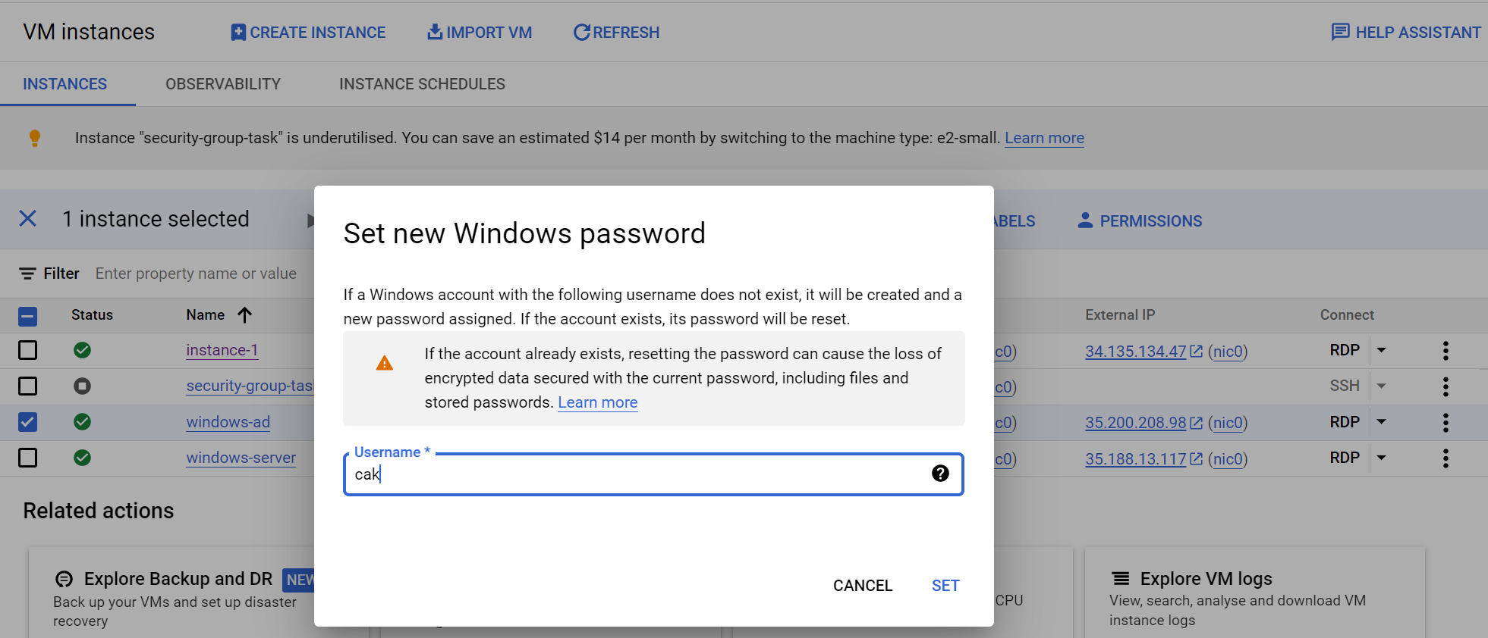

# Step 1 -

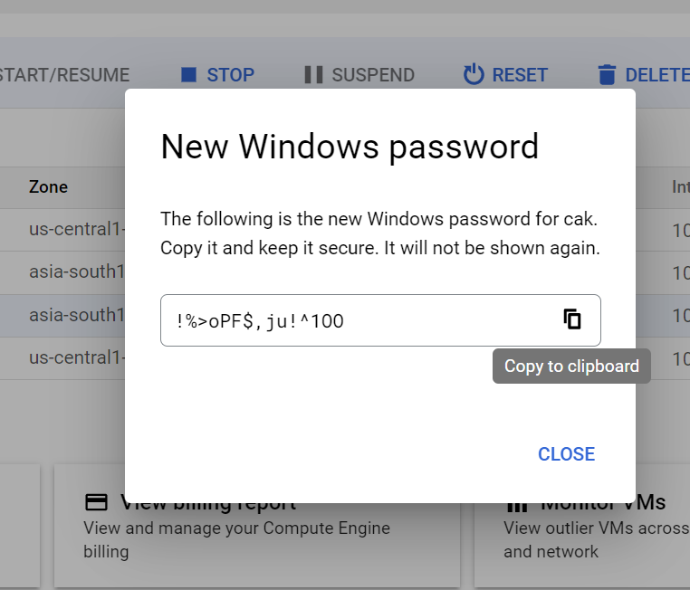

# Step 1 -

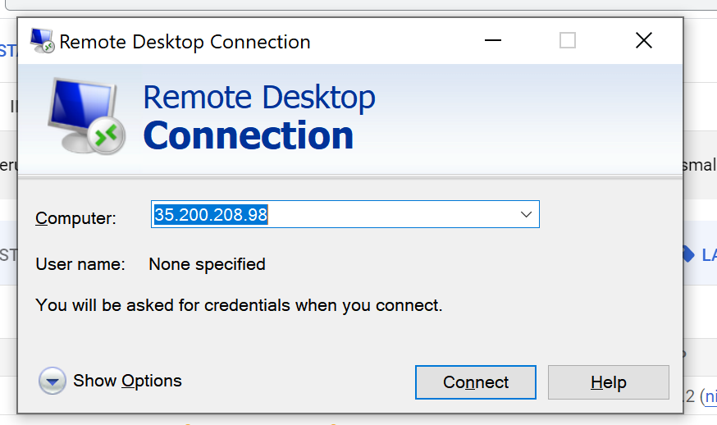

# Step 1 -

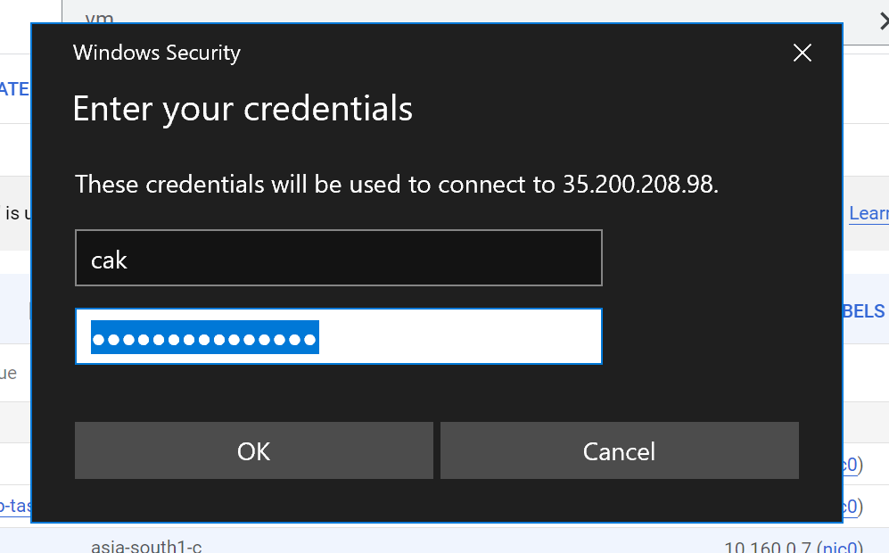

# Step 1 -



# Step 1 -

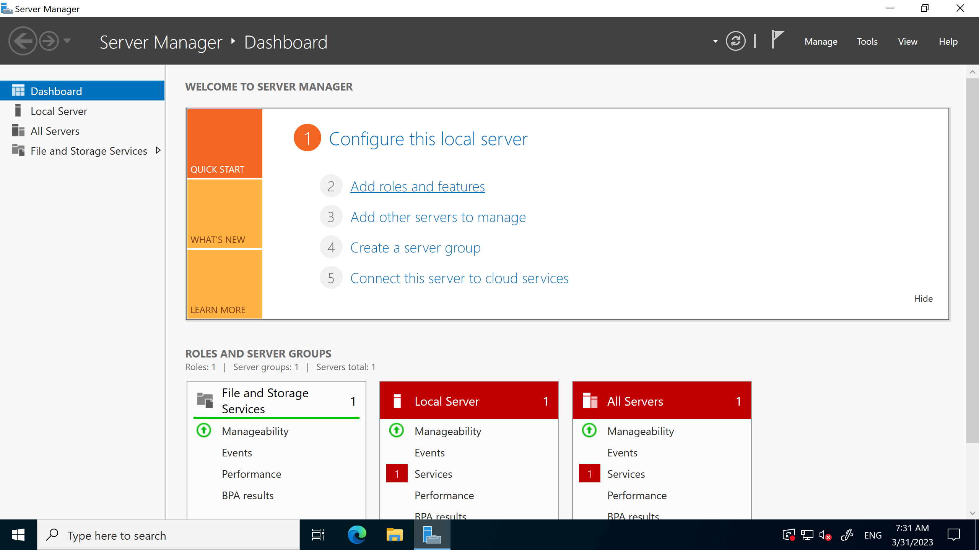

# Step 1 -

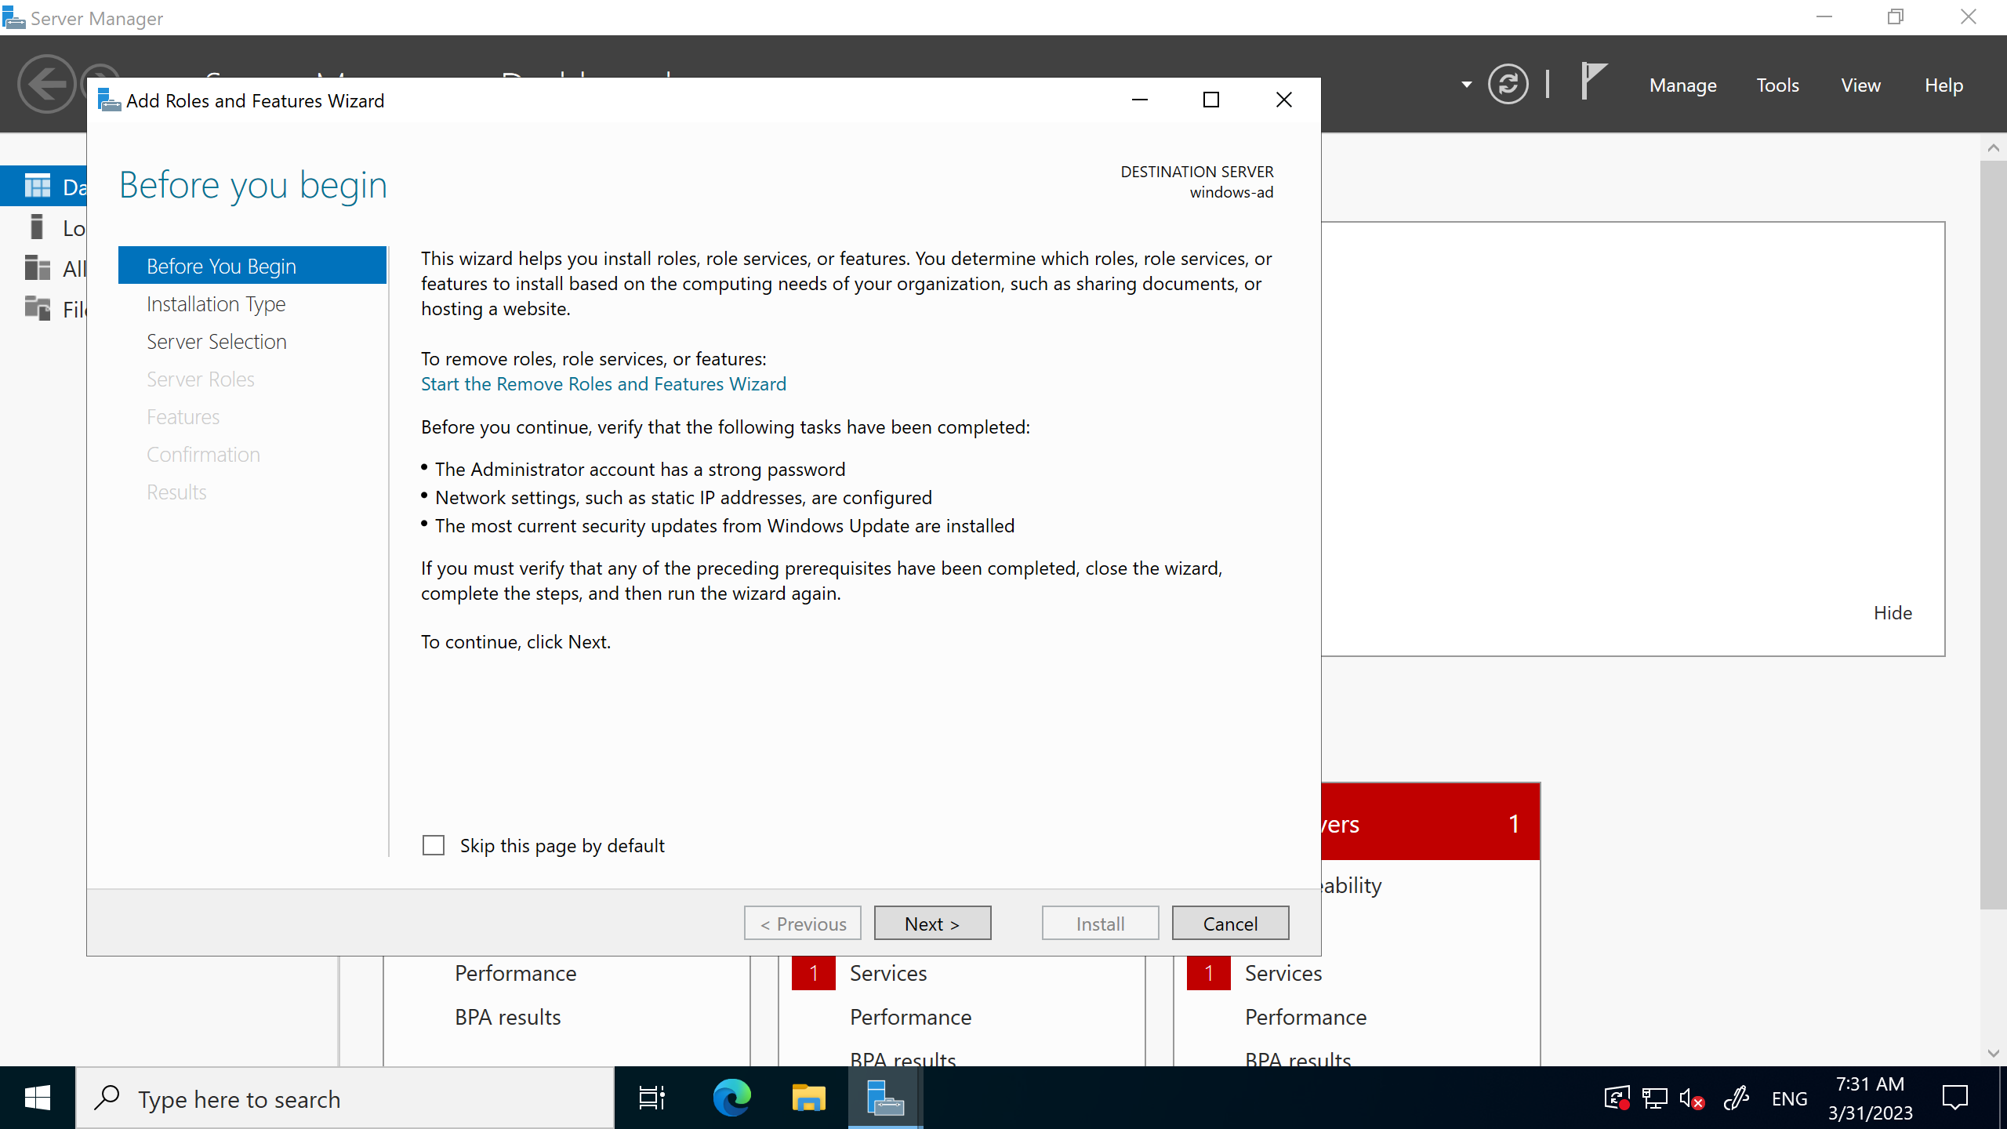

# Step 1 -

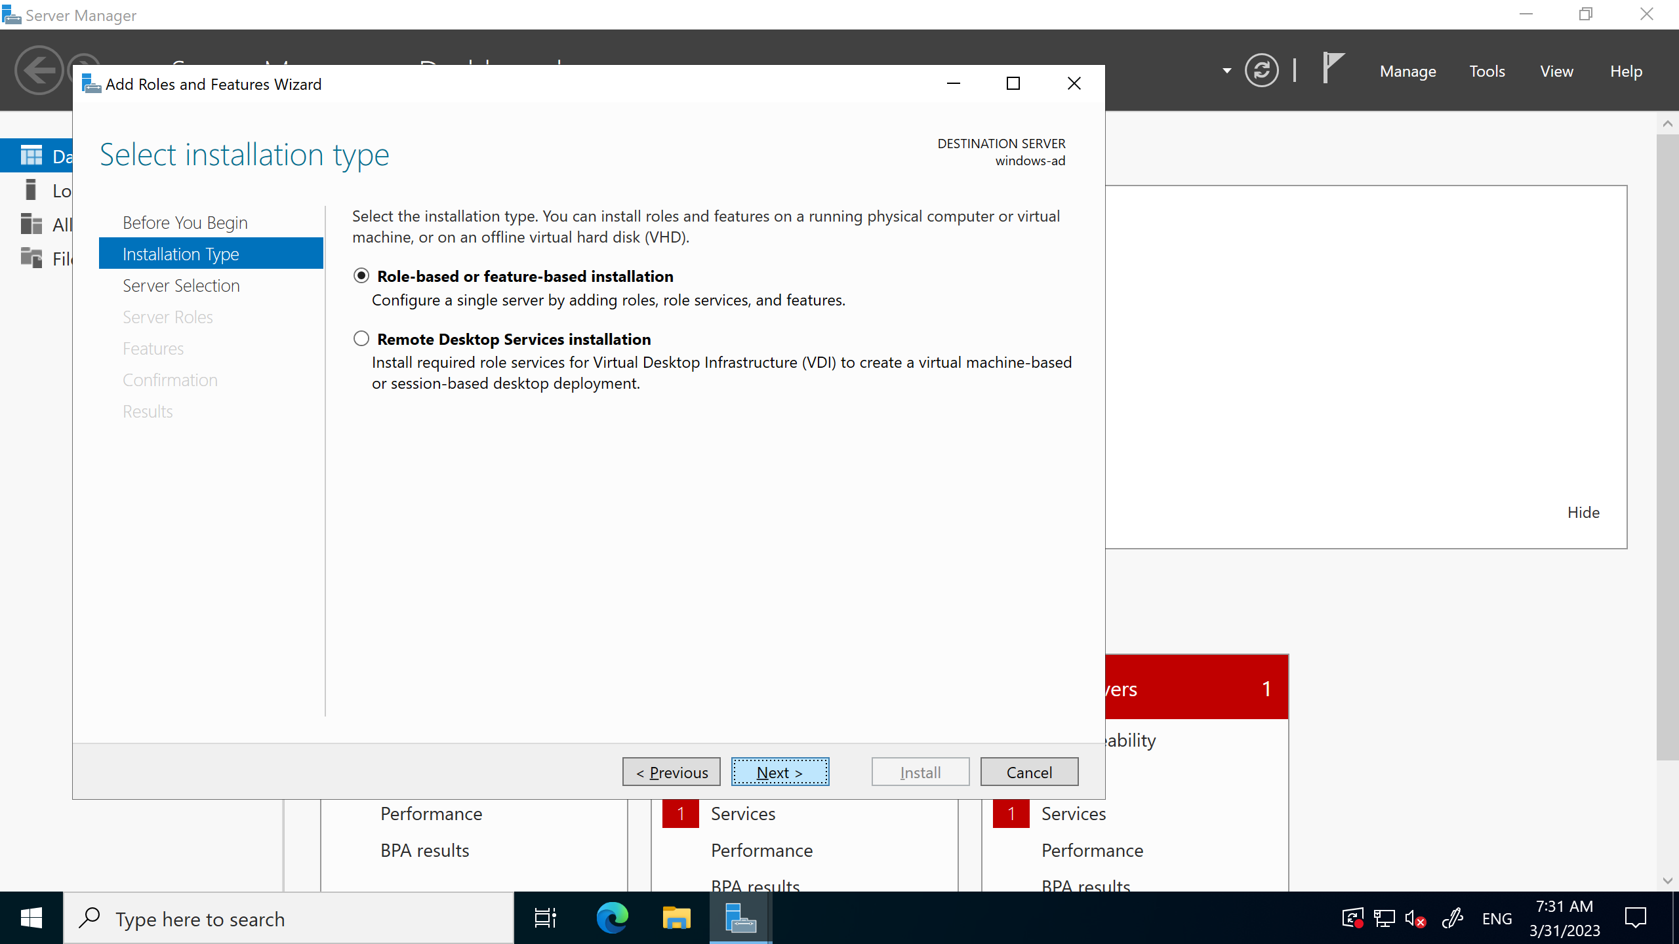

# Step 1 -

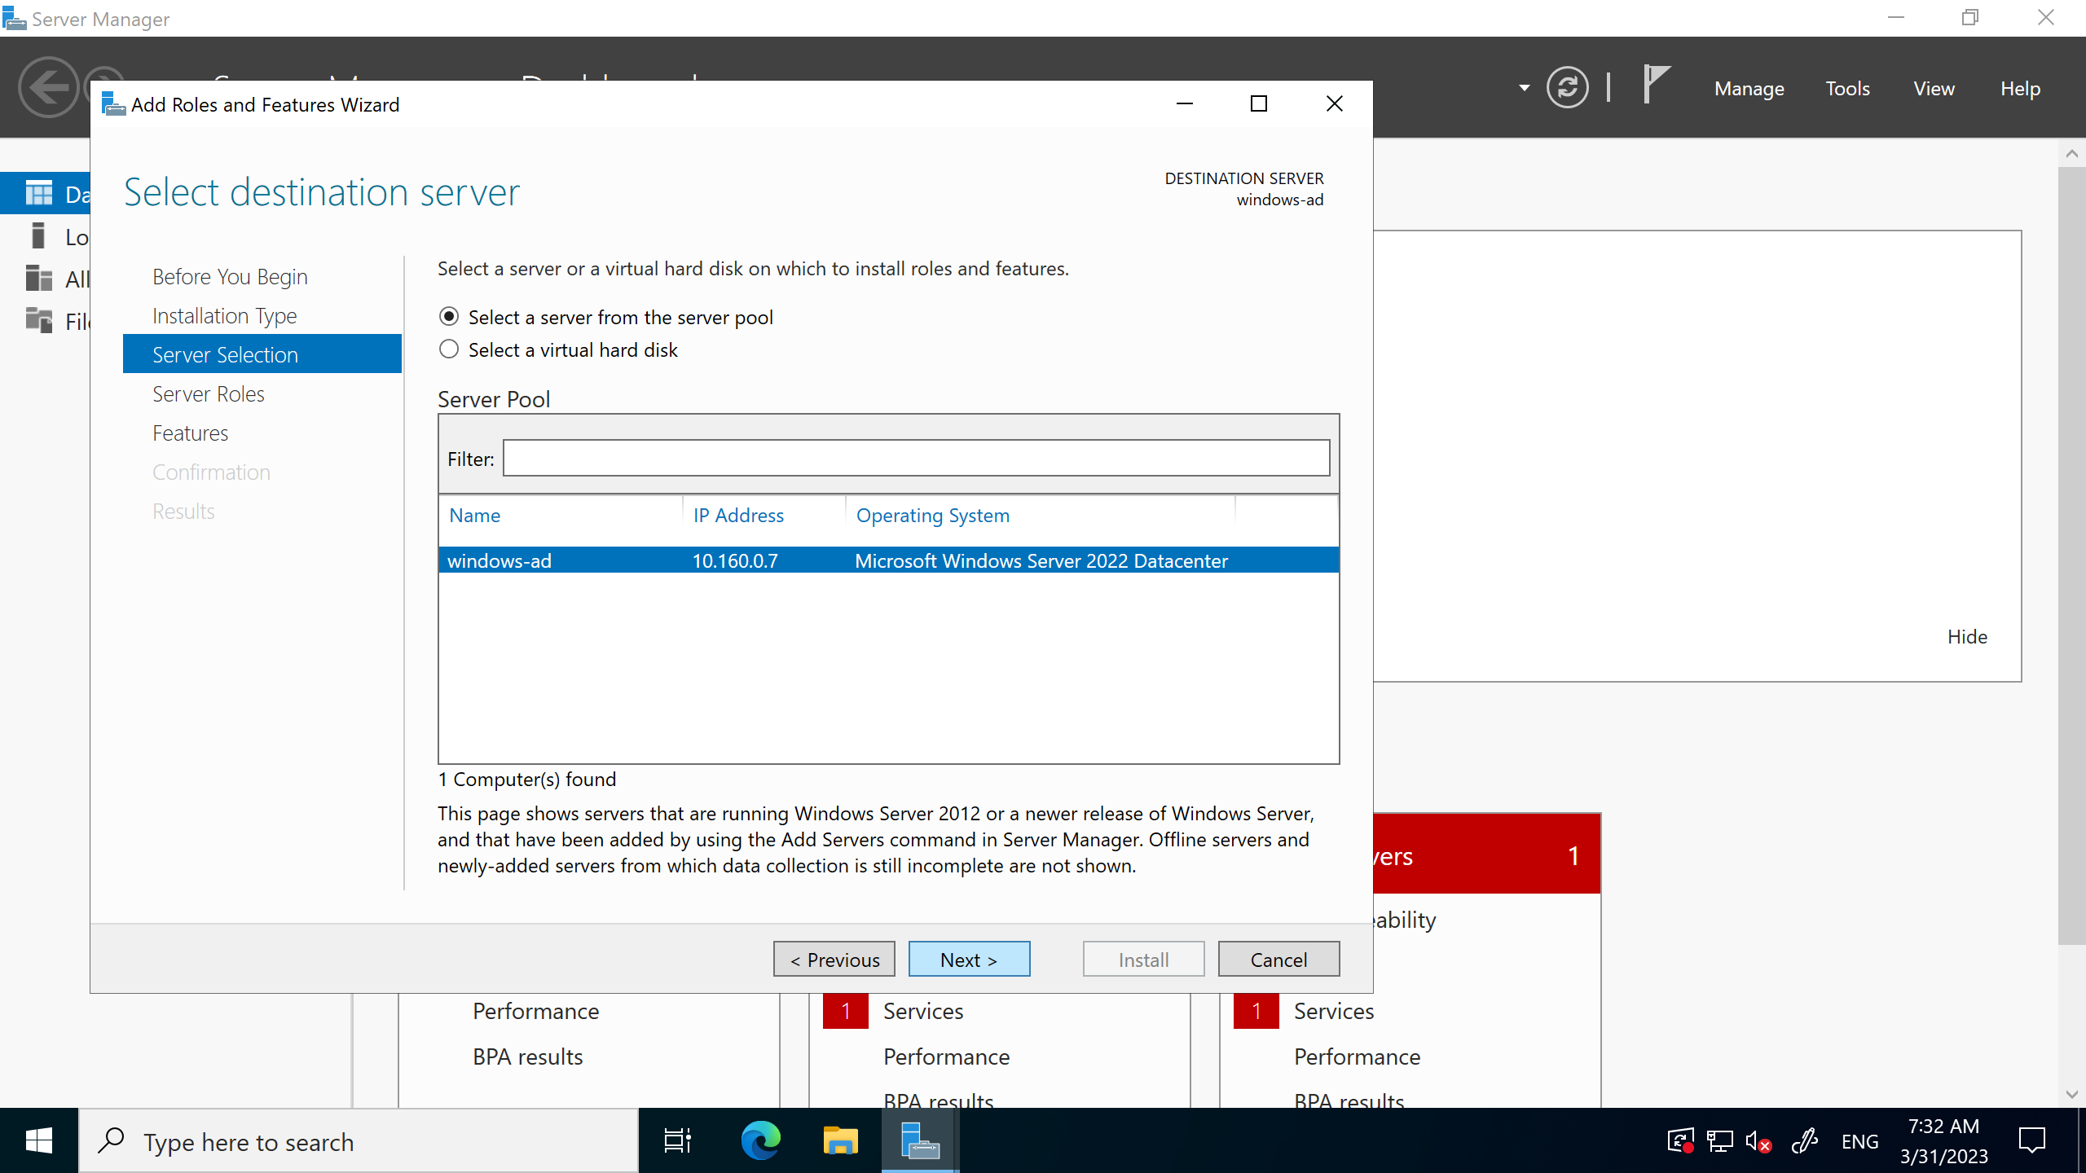

# Step 1 -

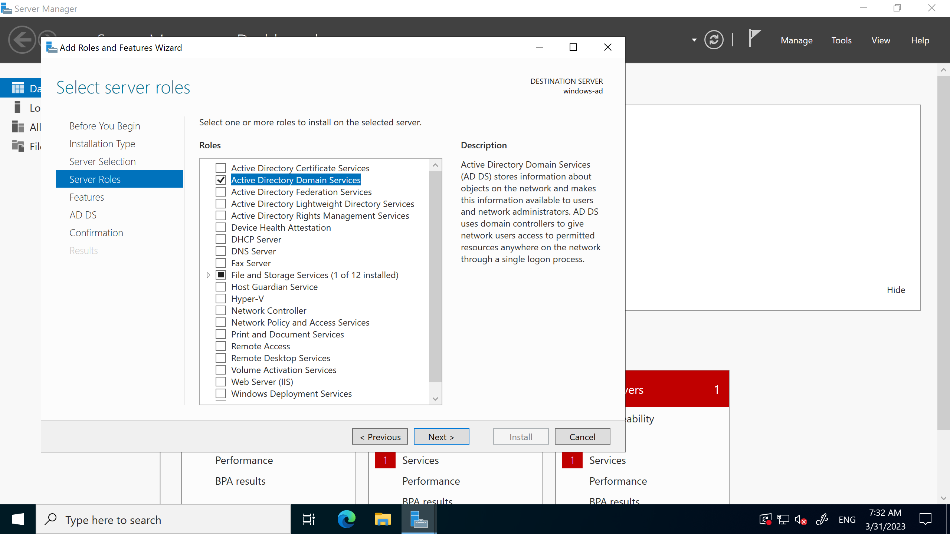

# Step 1 -

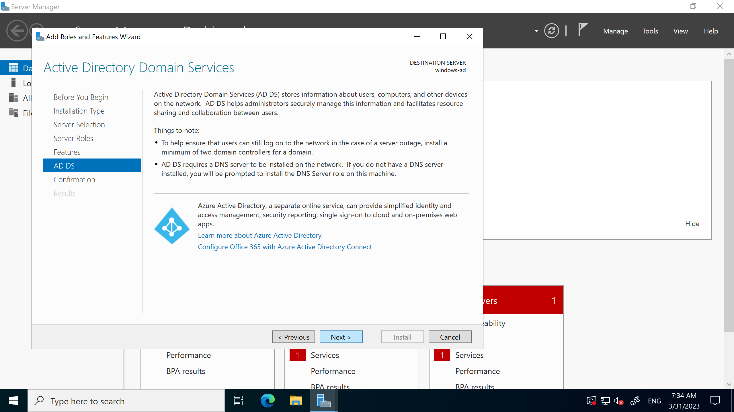

# Step 1 -

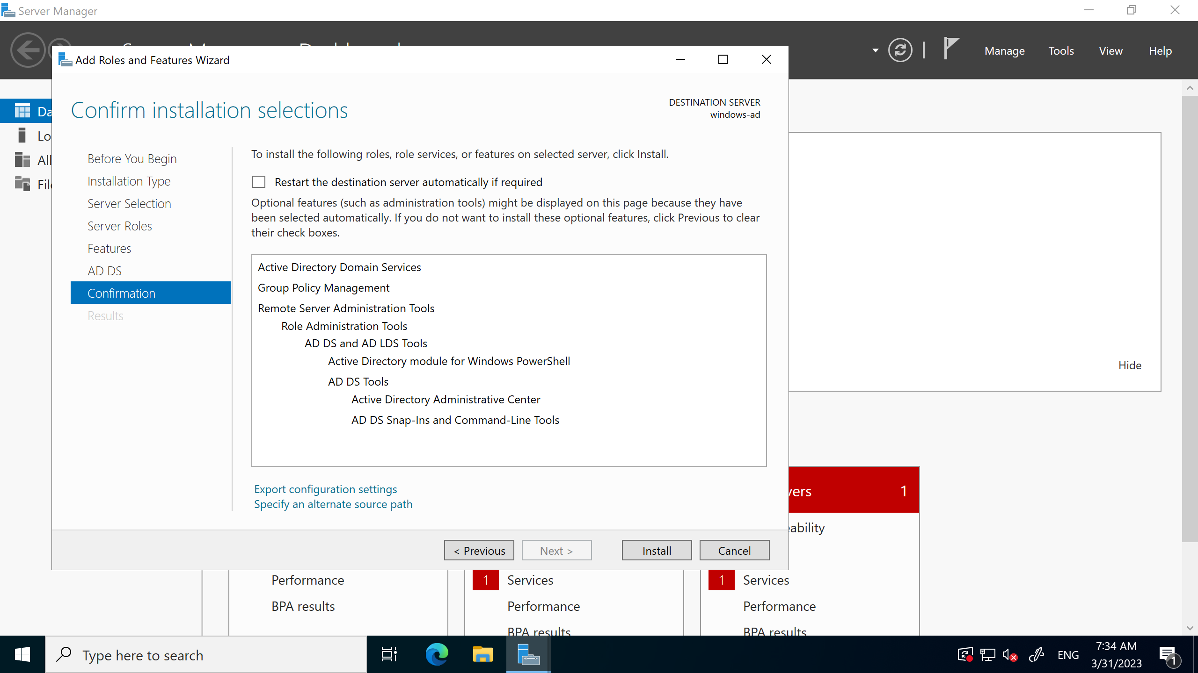

# Step 1 -

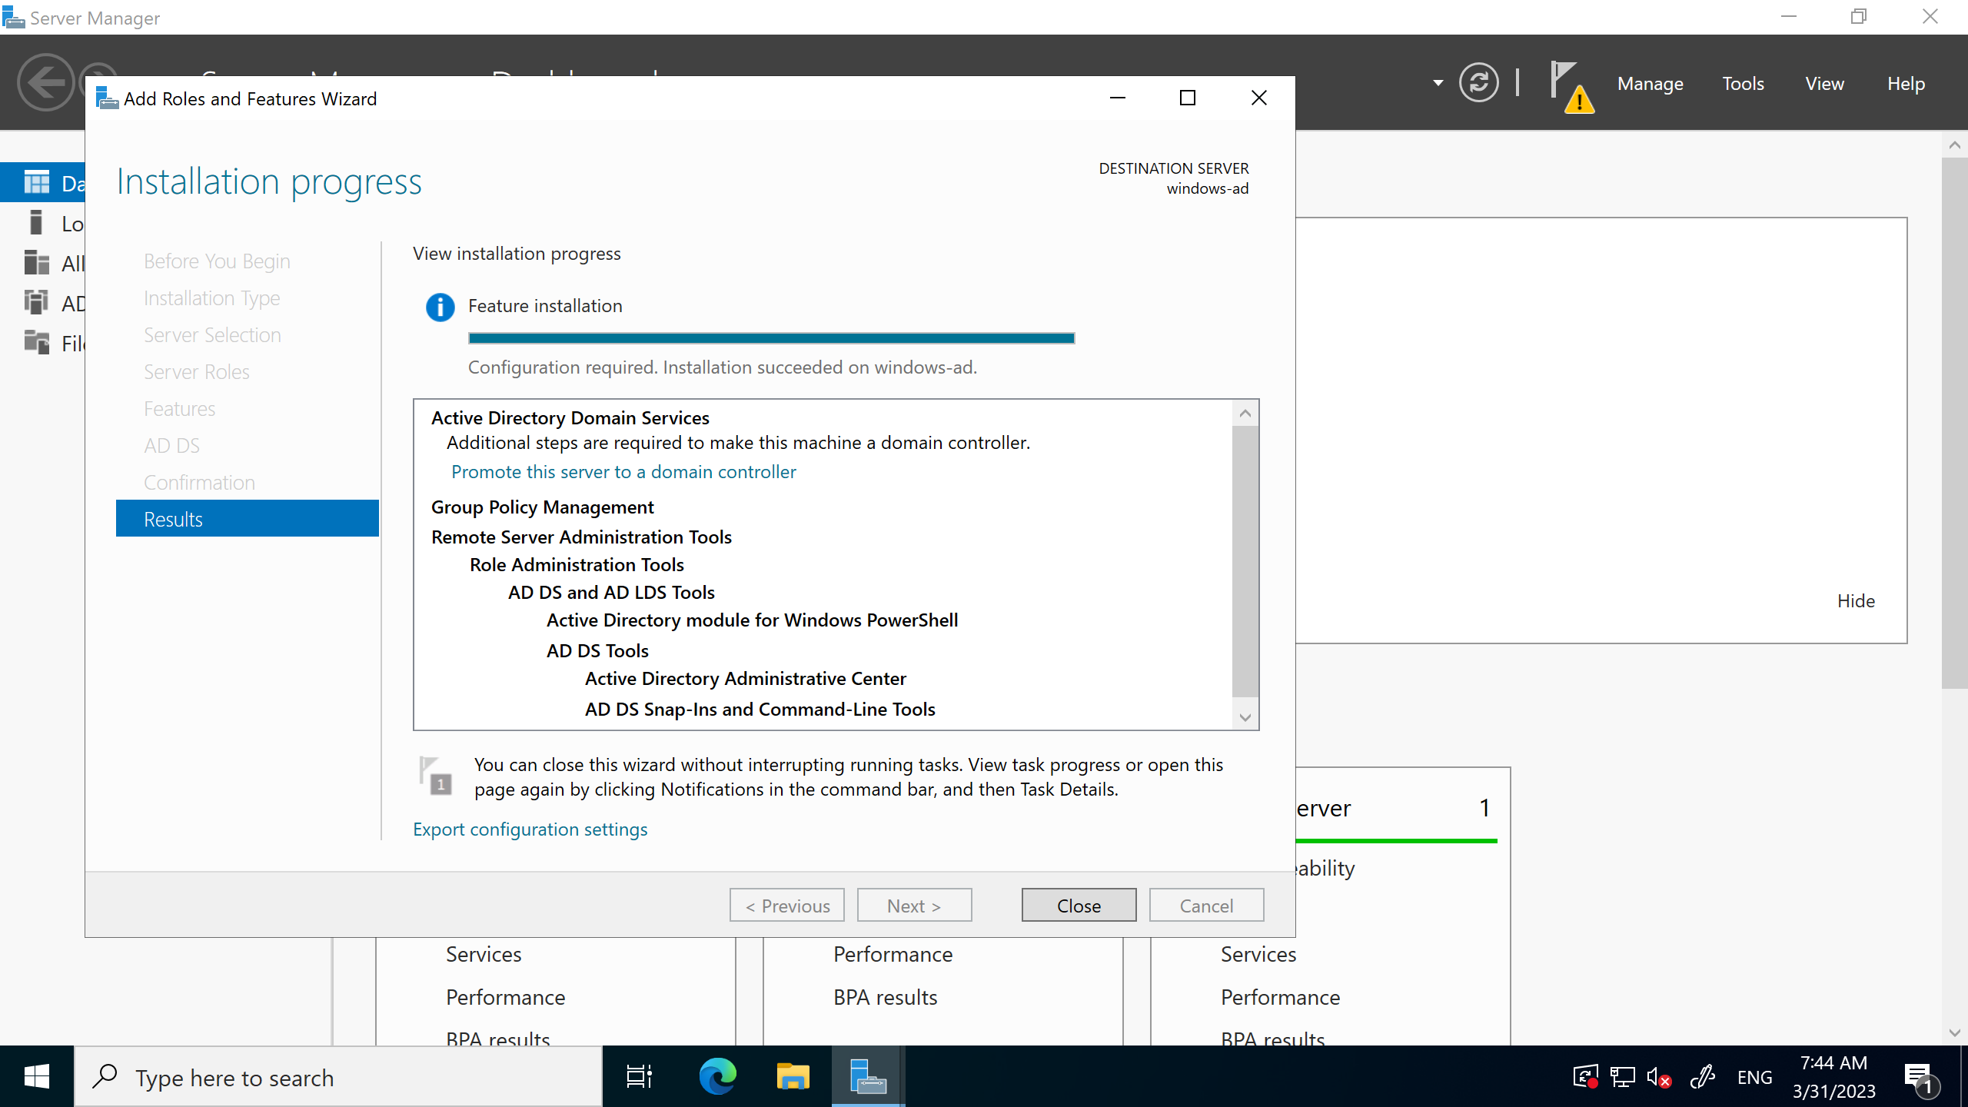

# Step 1 -

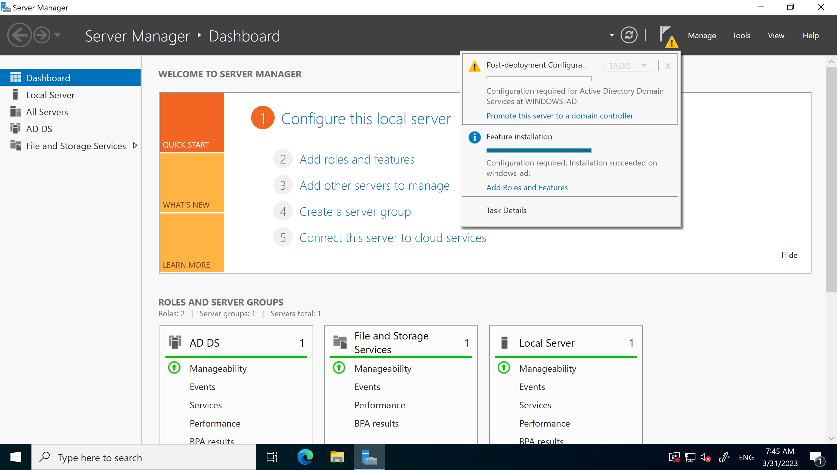

# Step 1 -

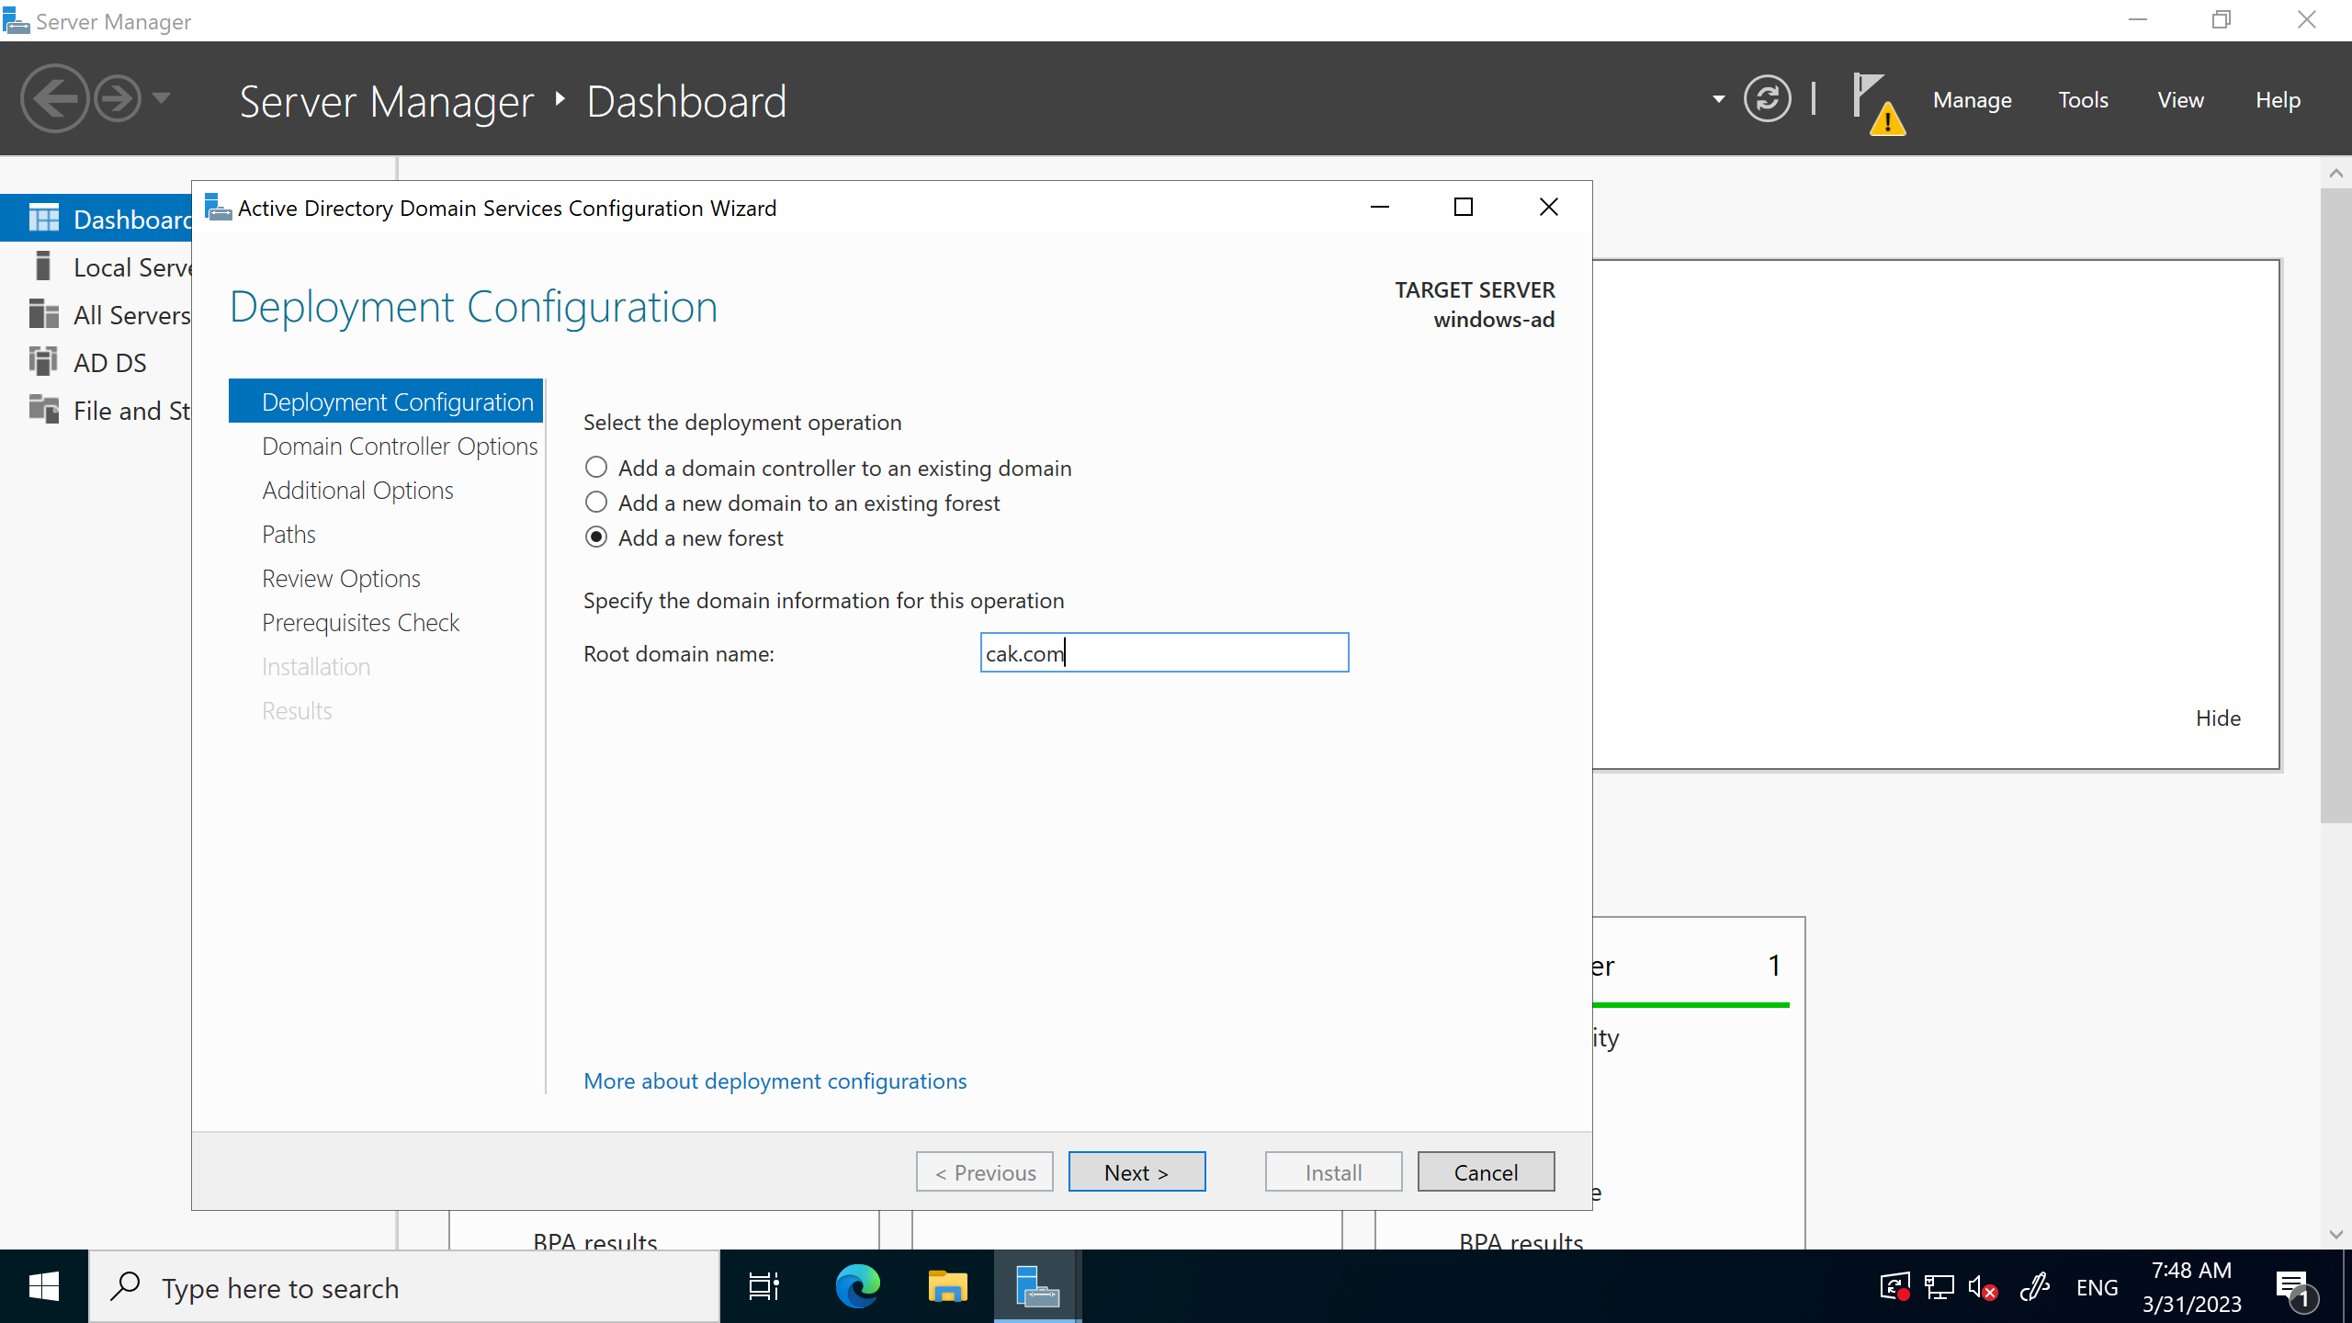

# Step 1 -

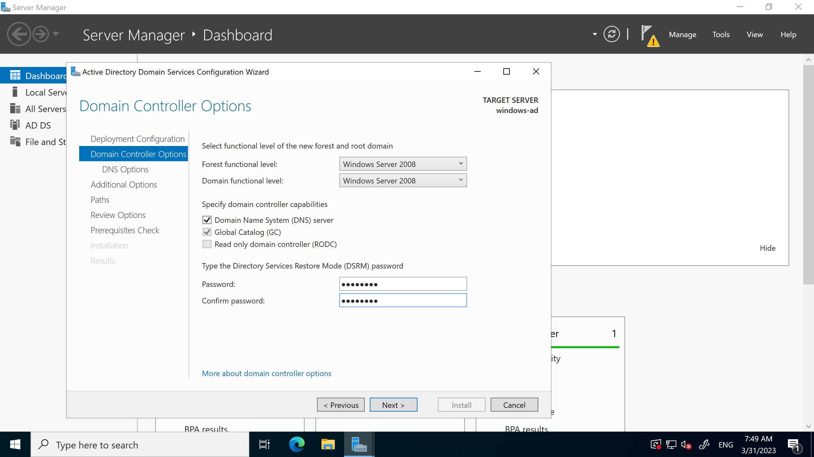

# Step 1 -

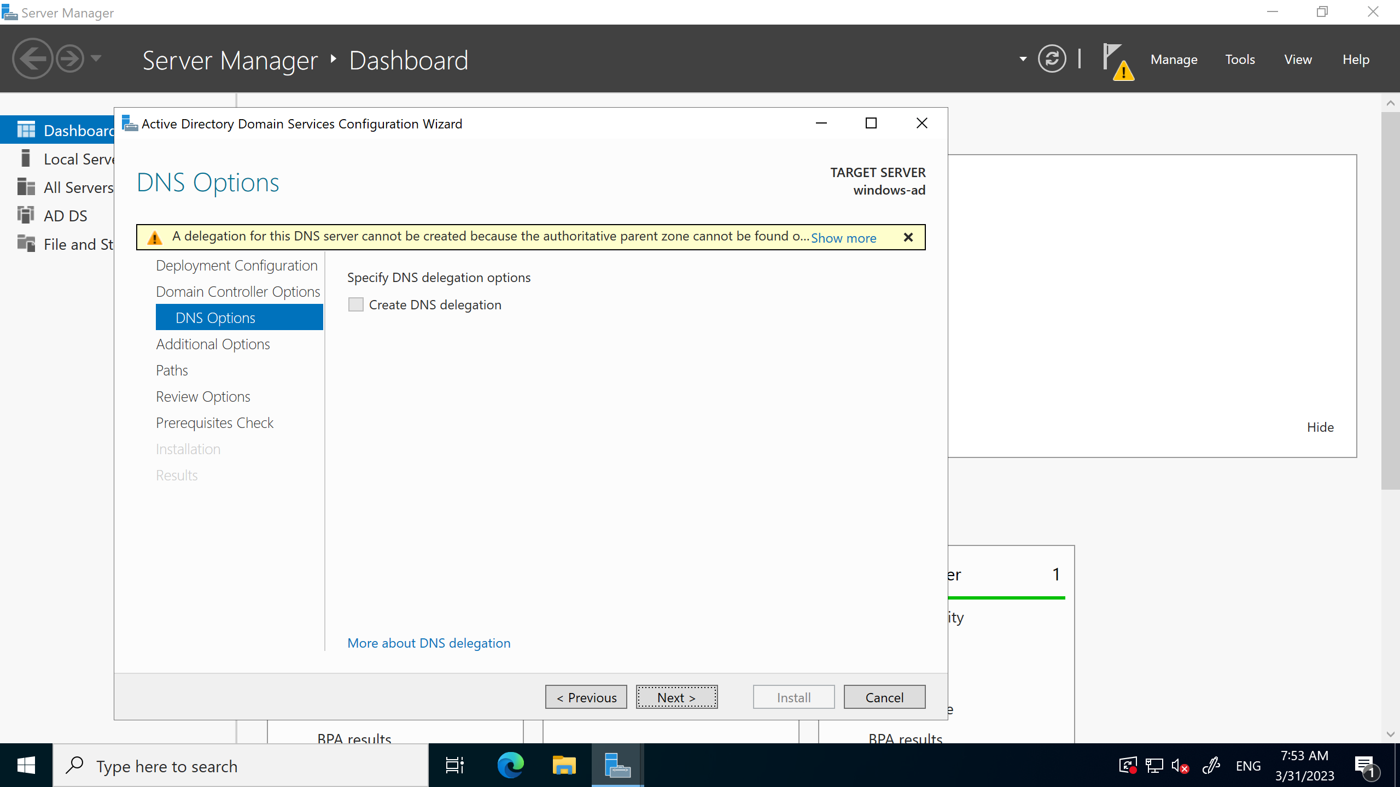

# Step 1 -

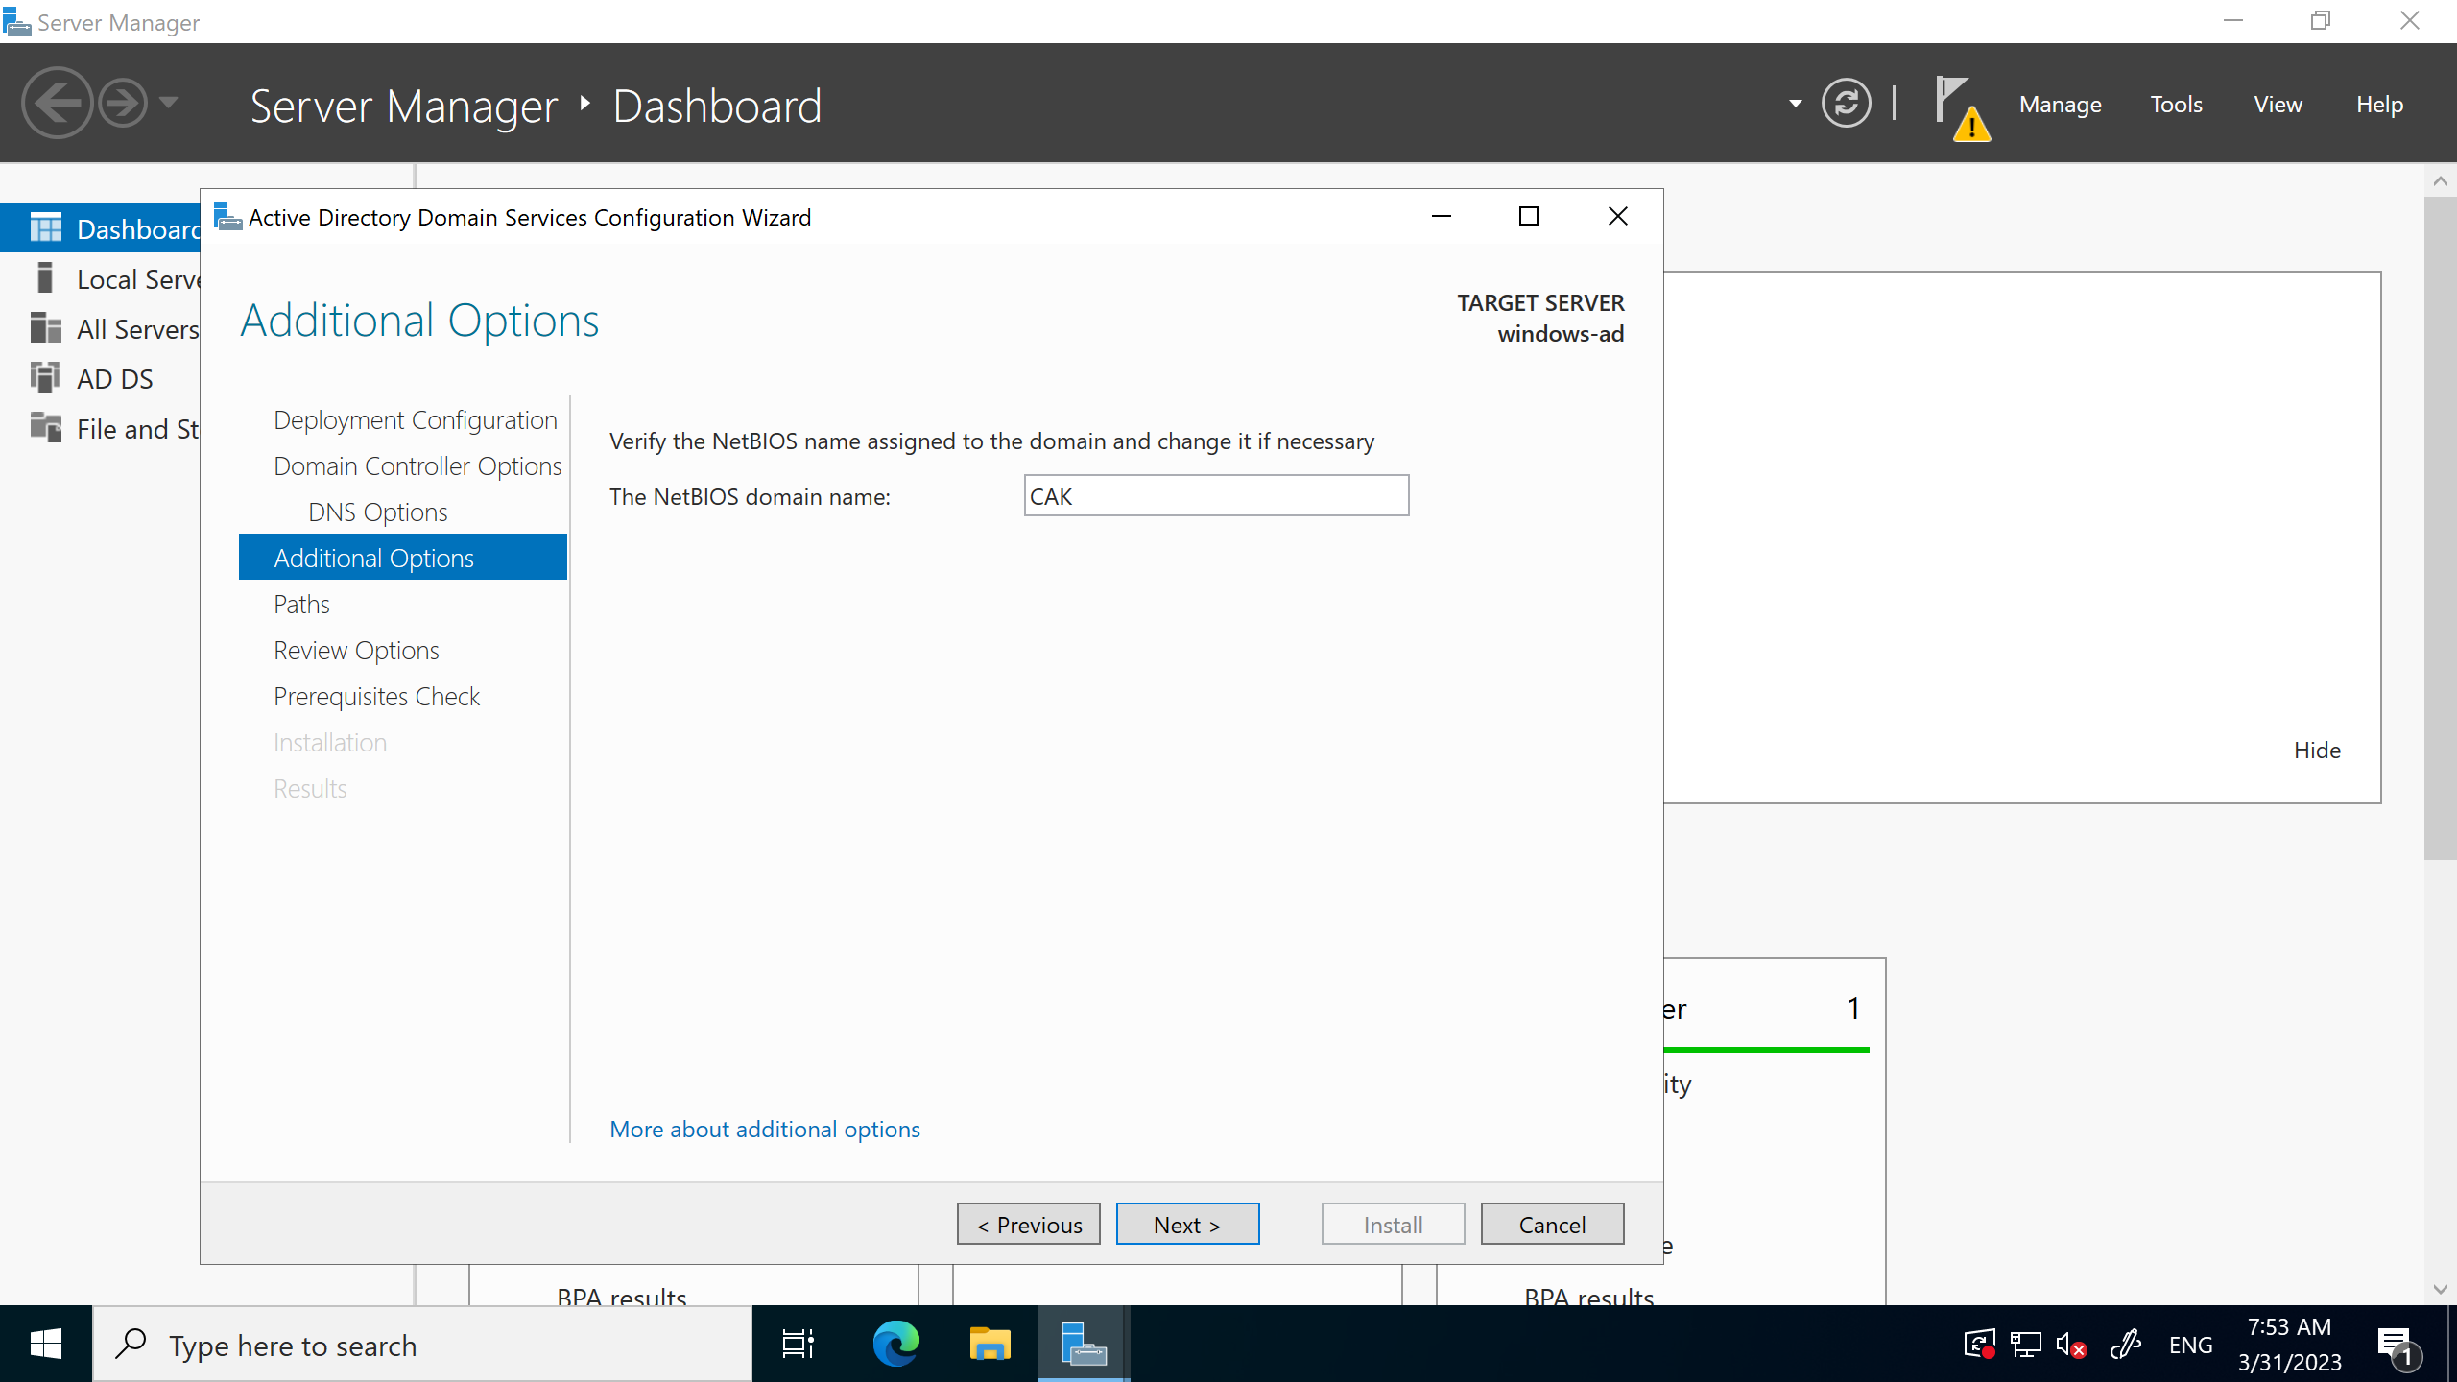

# Step 1 -

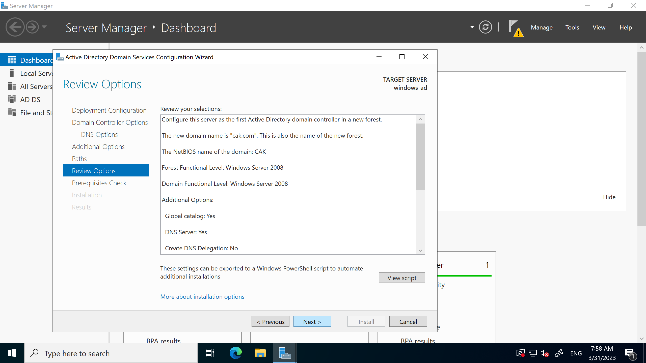

# Step 1 -

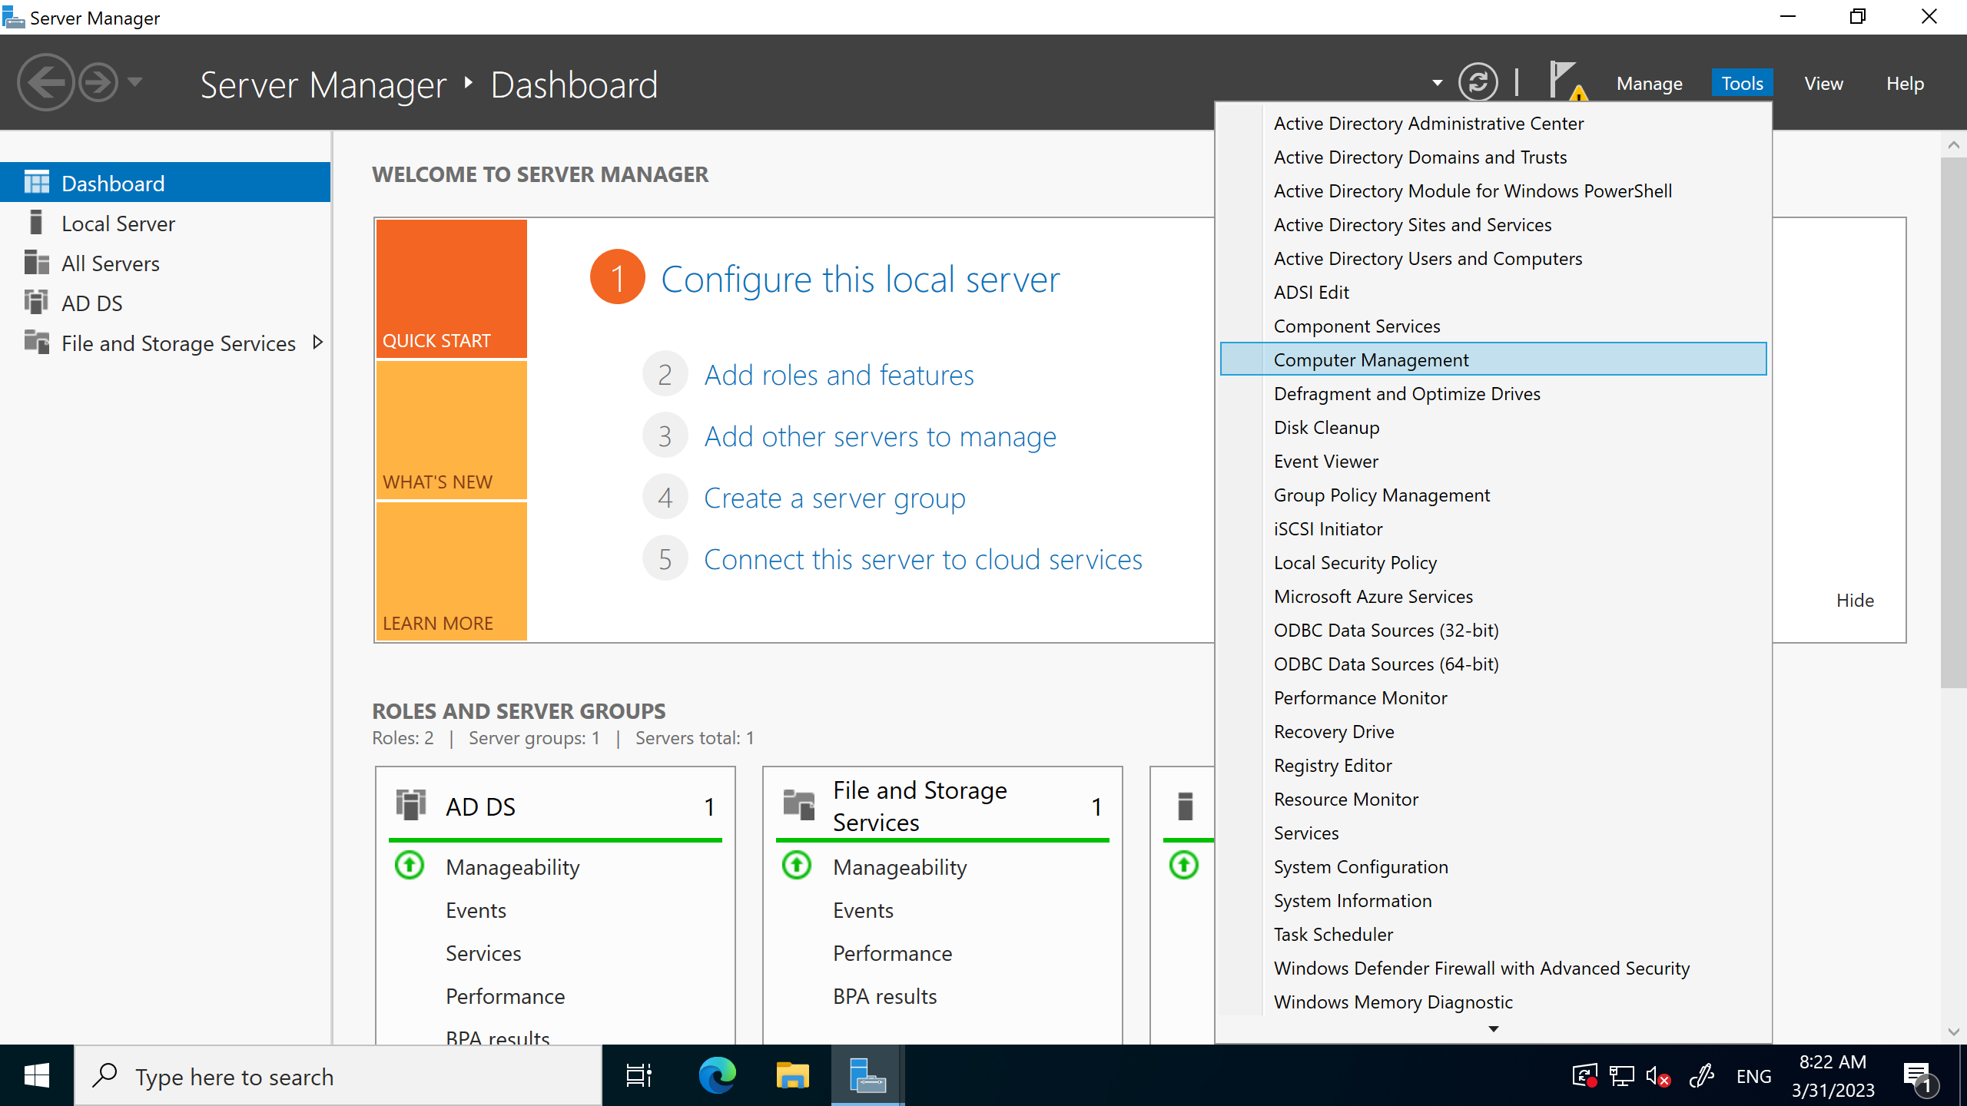

# Step 1 -

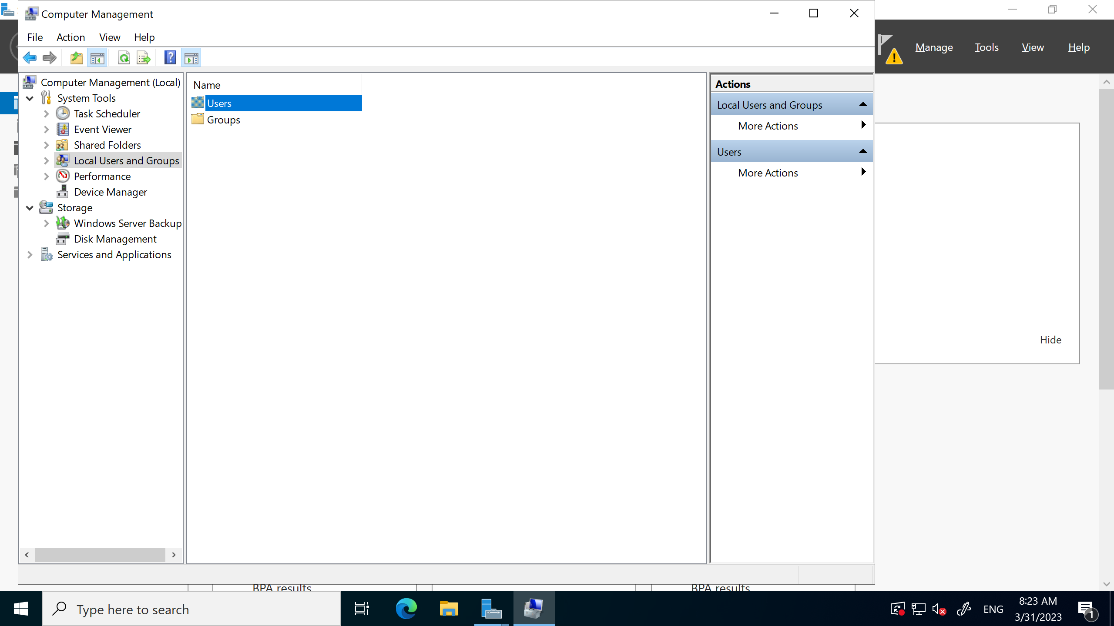

# Step 1 -

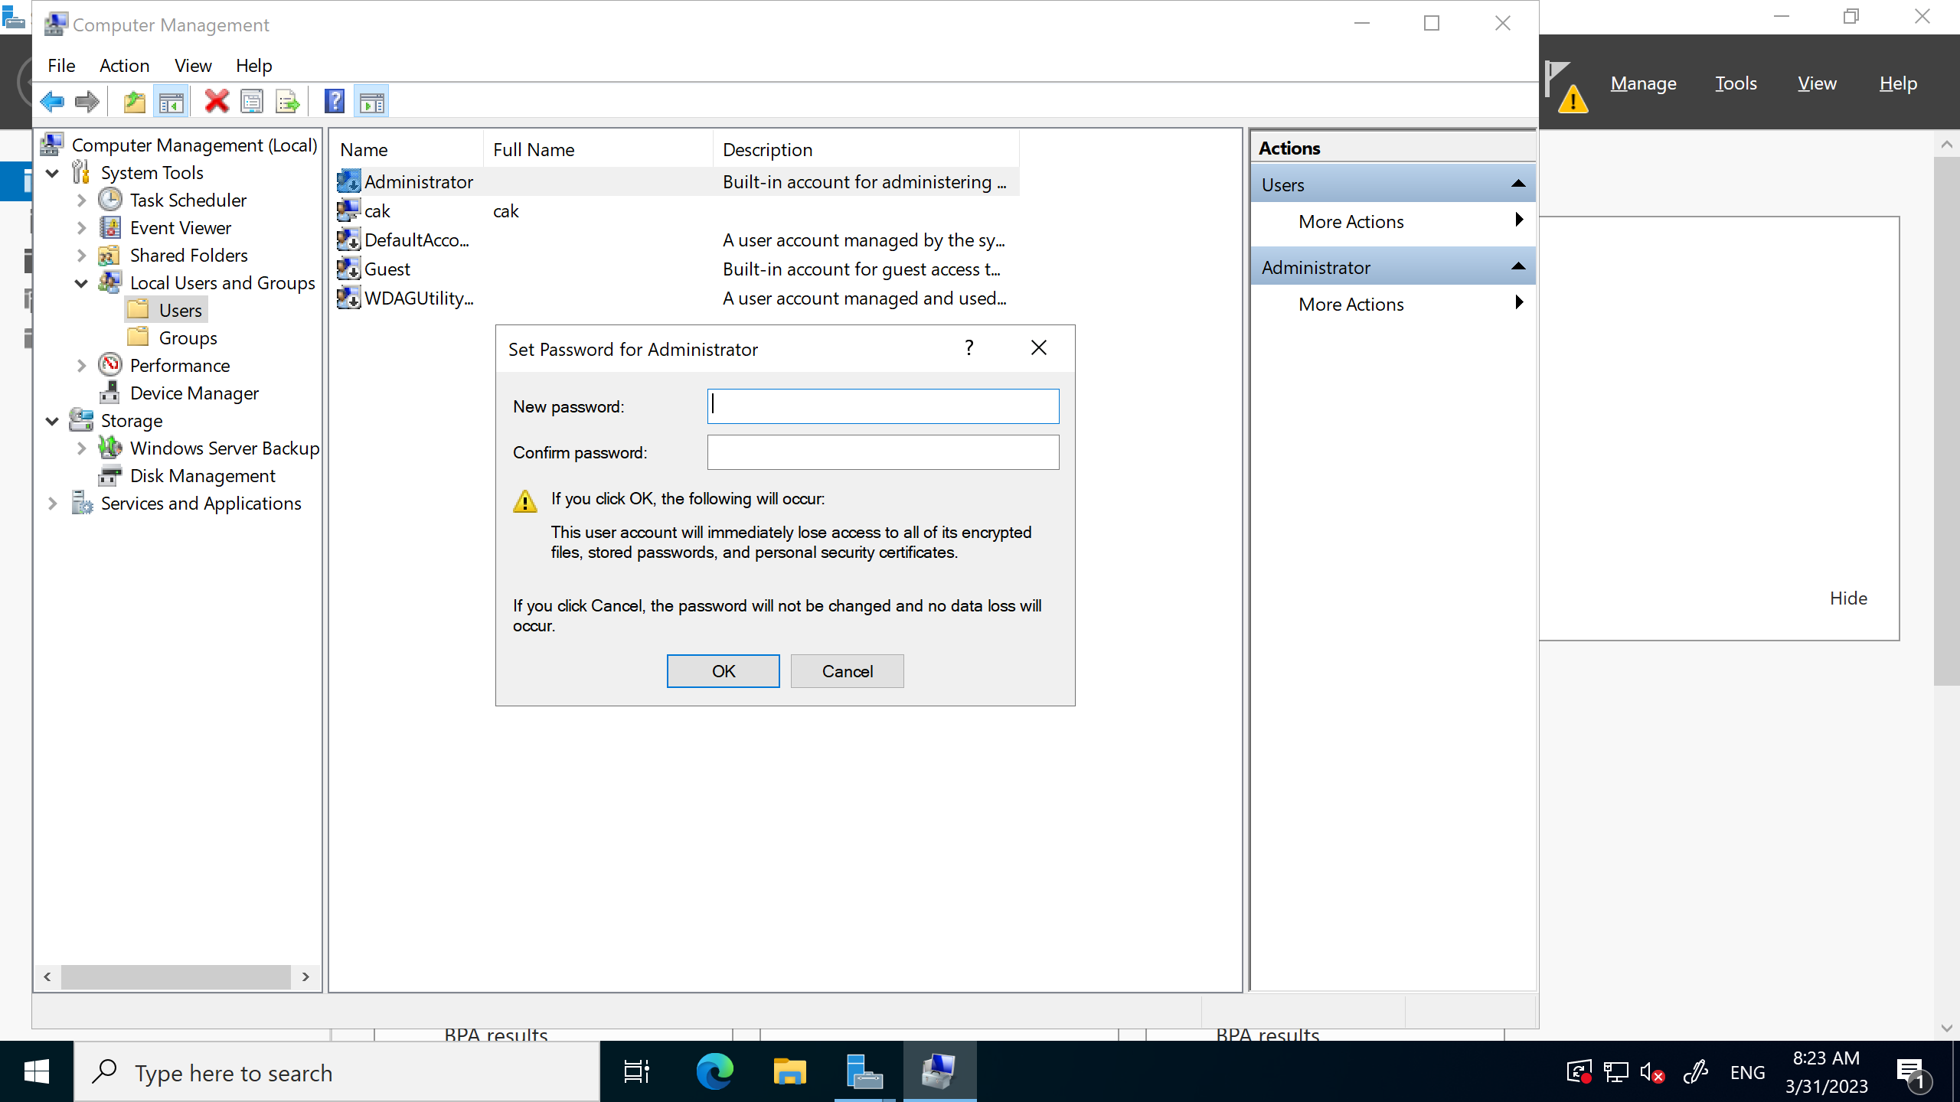

# Step 1 -

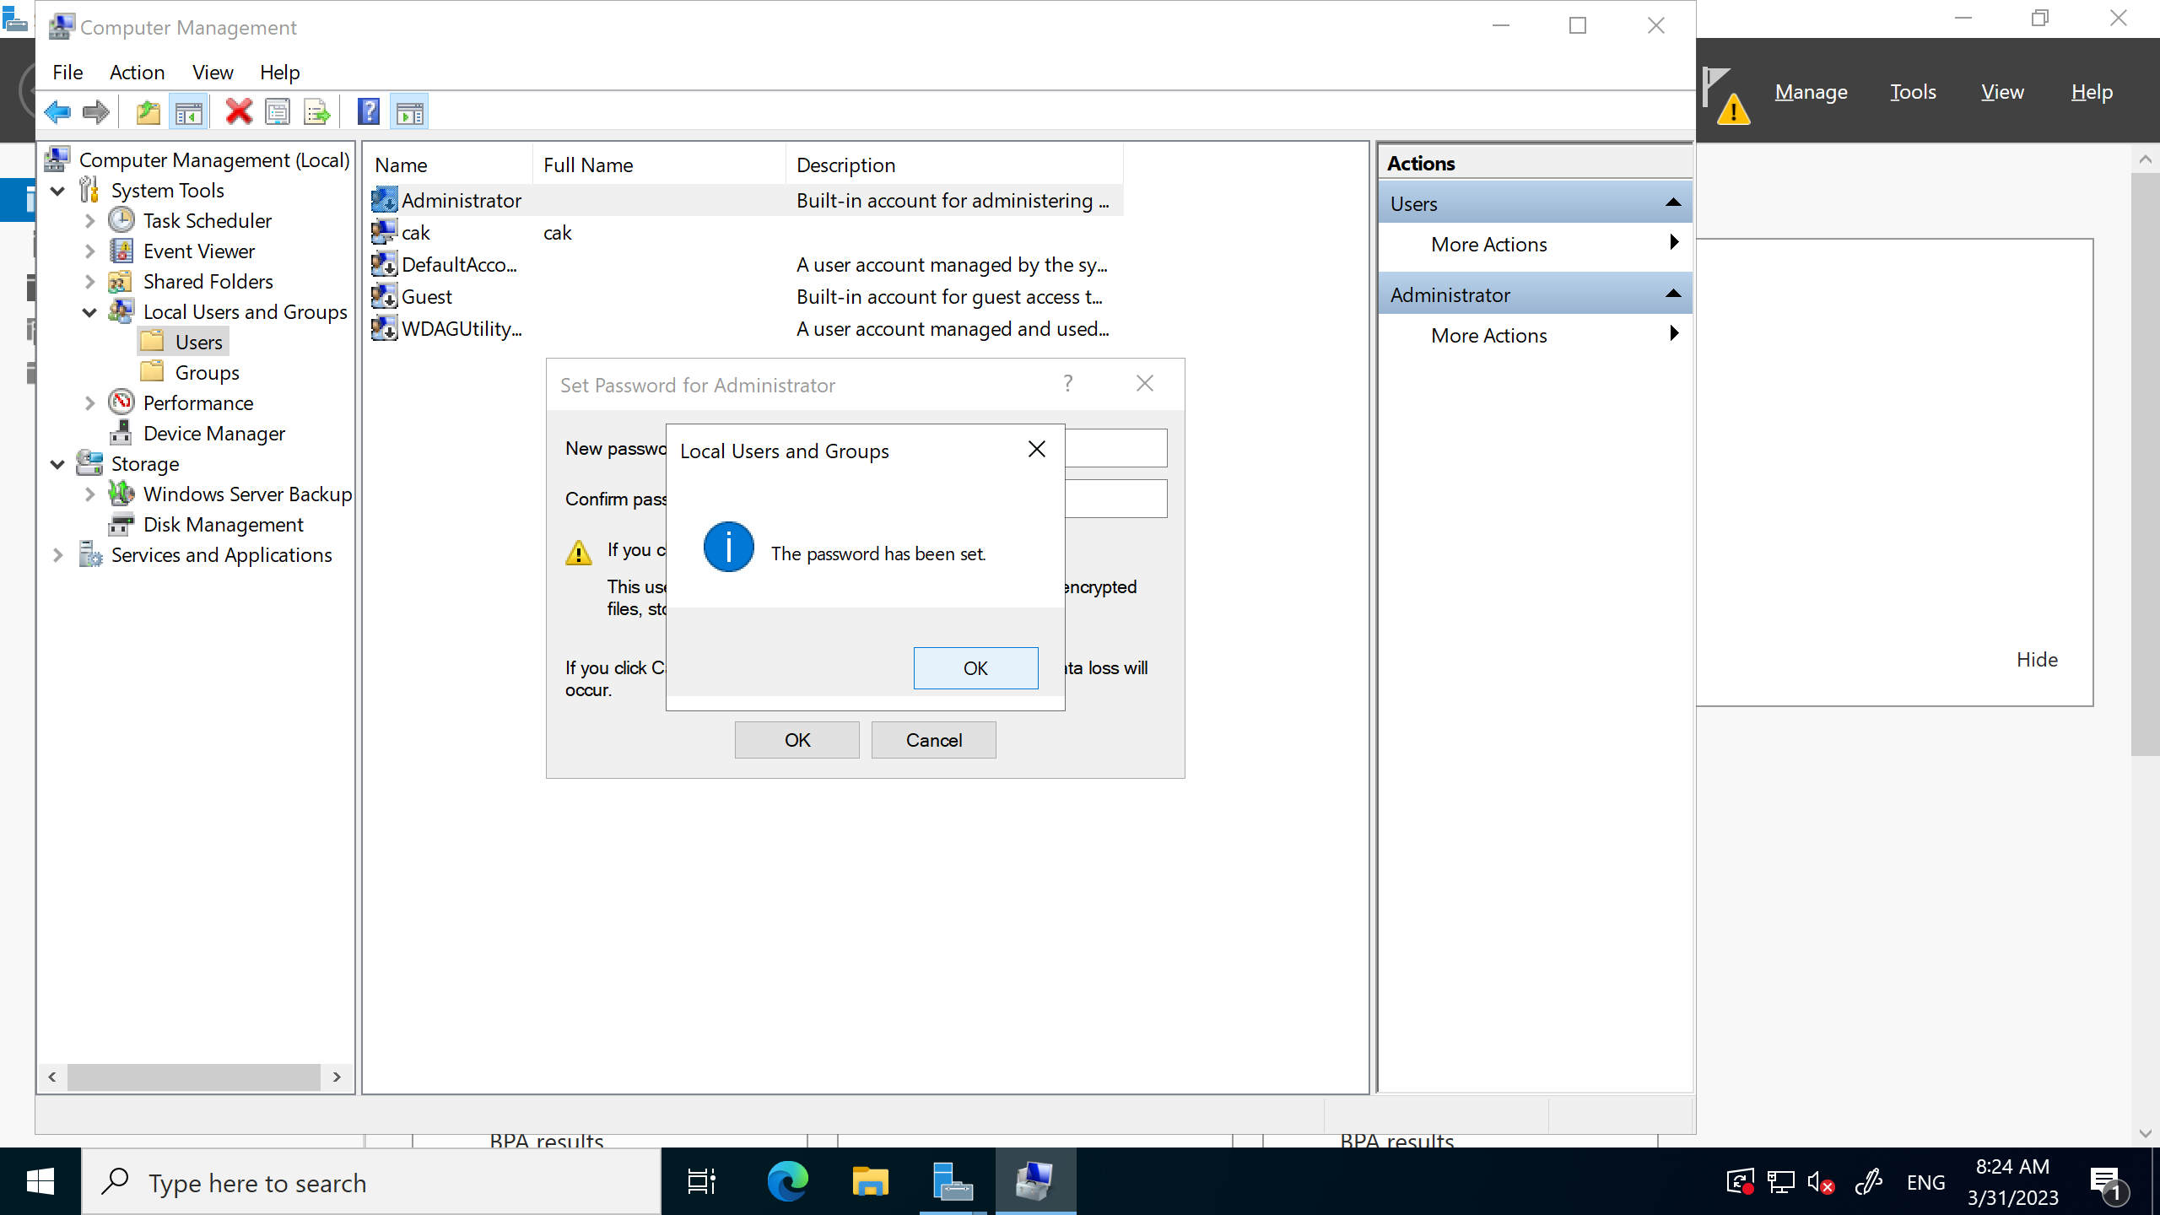

# Step 1 -

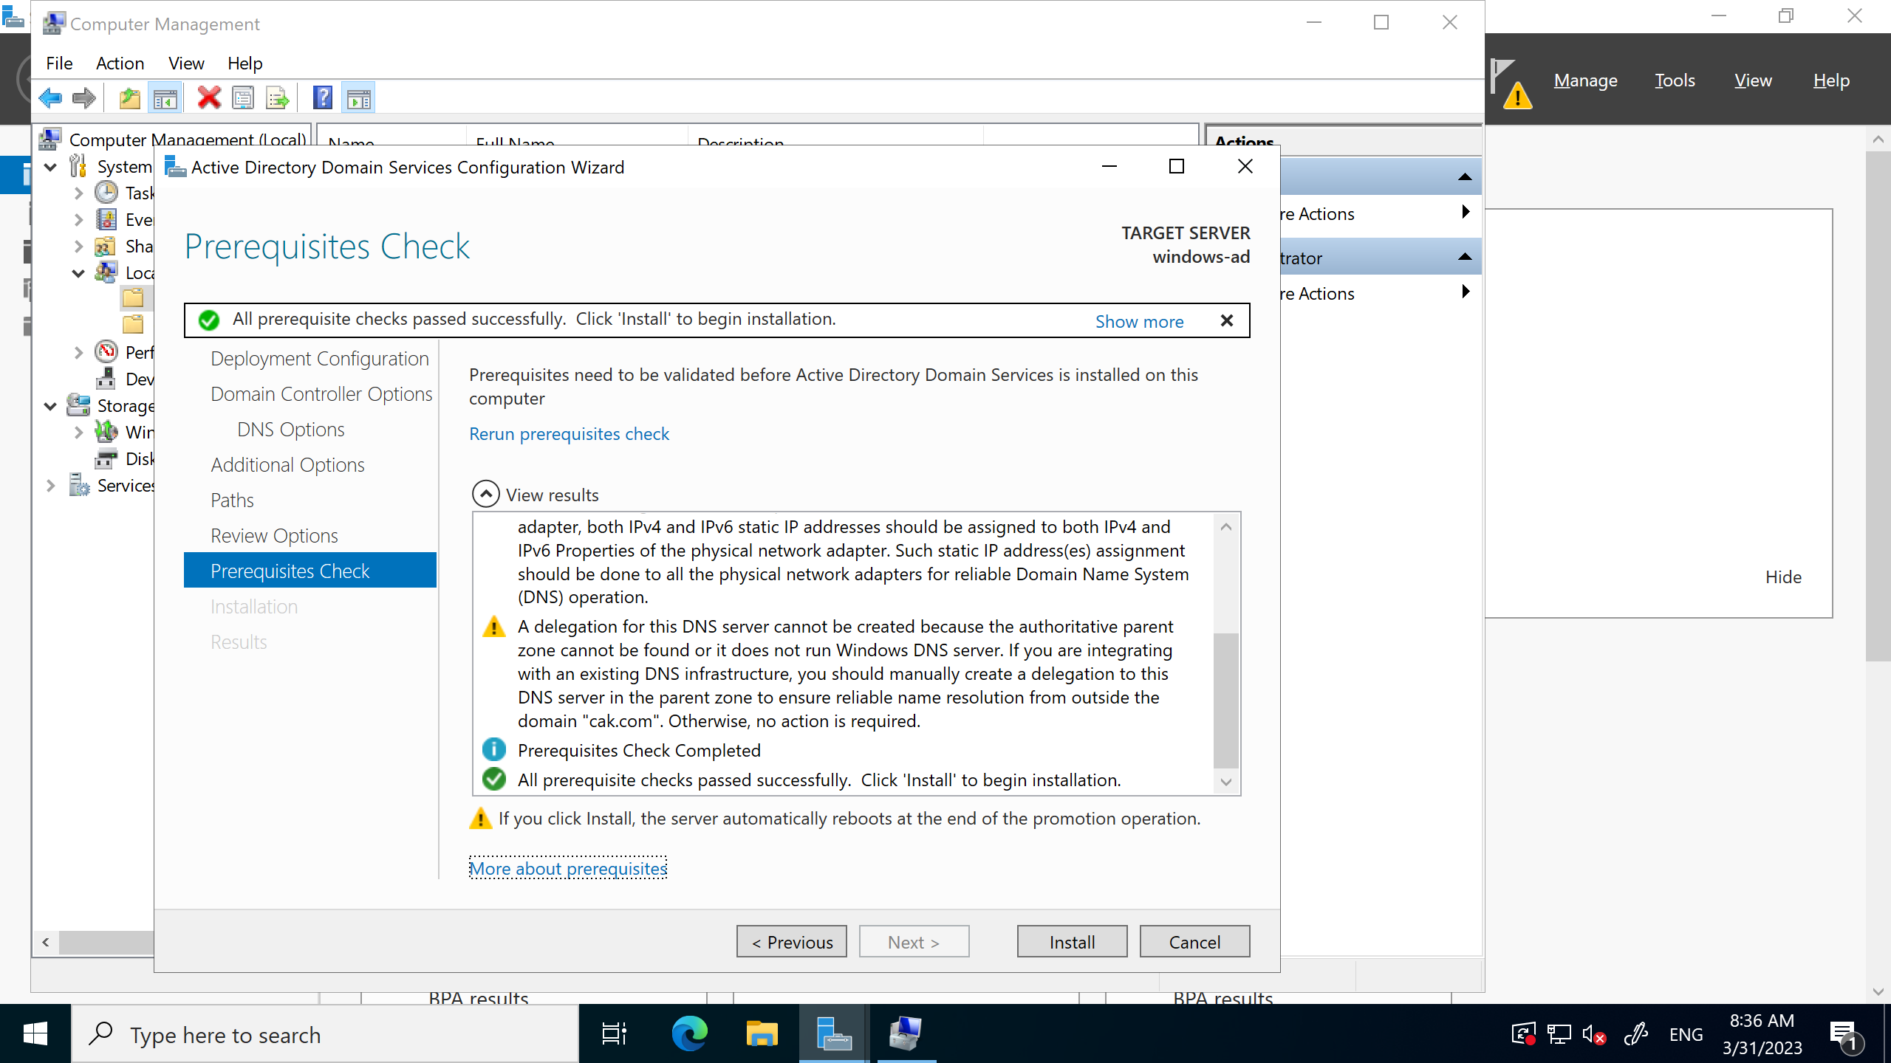

# Step 1 -

# Step 1 -

# Step 1 -

# Step 1 -

# Step 1 -

# Step 1 -

# Step 1 -

# Step 1 -

# Step 1 -

# Step 1 -

# Step 1 -

# Outputs

* Activity status (Perform, test, troubleshoot, review).
* Document the hours spent to perform the entire activity.

# Exit Criteria

* Notify customer about the completion.
* Customers test the outcome and gives feedback.